**SPRINT 4**

|  |  |
| --- | --- |
| Date | 03 November 2022 |
| Team ID | PNT2022TMID40580 |
| Project Name | DETECTING PARKINSON’S DISEASE USING  MACHINE LEARNING |
| Maximum Marks | 4 Marks |

7. Initialize an XGBClassifier and train the model. This classifies using extreme Gradient Boosting- using[gradient boosting algorithms](https://data-flair.training/blogs/gradient-boosting-algorithm/)for modern data science problems. It falls under the category of Ensemble Learning in ML, where we train and predict using many models to produce one superior output.

* #DataFlair - Train the model
* model=XGBClassifier()
* model.fit(x_train,y_train)

**Output Screenshot:**

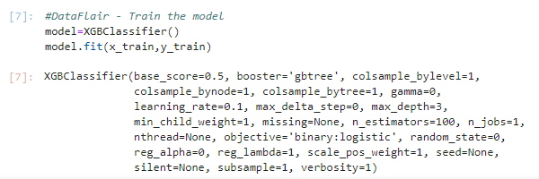

8. Finally, generate y_pred (predicted values for x_test) and calculate the accuracy for the model. Print it out.

* # DataFlair - Calculate the accuracy
* y_pred=model.predict(x_test)
* print(accuracy_score(y_test, y_pred)*100)

**Output Screenshot:**

